ST. ERVAN PARISH COUNCIL
Jacqui Peskett
Parish Clerk

Email: stervanpc@outlook.com
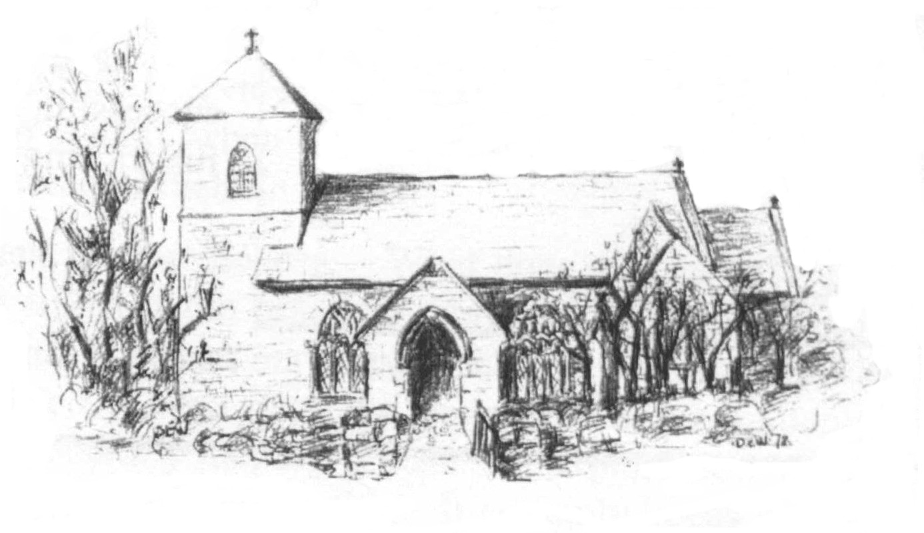

24th December 2024

I hereby give notice that the ORDINARY MEETING of ST ERVAN PARISH COUNCIL will be held at St Ervan Village Hall on Tuesday 7th January 2025 at 7.00pm

All members of the Council are hereby summoned to attend for the purposes of considering and resolving upon the business about to be transacted at the meeting as set out in the agenda.

Jacqui Peskett
Clerk/RFO to St Ervan Parish Council

Public Participation (15 mins)

AGENDA

Apologies and Announcements

Declarations of interest

Minutes of St Ervan Parish Council Meeting 5th November 2024

Matters Arising & Correspondence

Planning Applications

Items for Information

Highways

Finance

Date Of Next Meeting: Tuesday 4th March 2025 @7.00pm

